**Twitter Overspending A/B testing**

**Observations and insights for questions:**

**Tasks:**

1. **How many campaigns have overspent of greater than 1% of their budget in the control group? In the treatment group?**

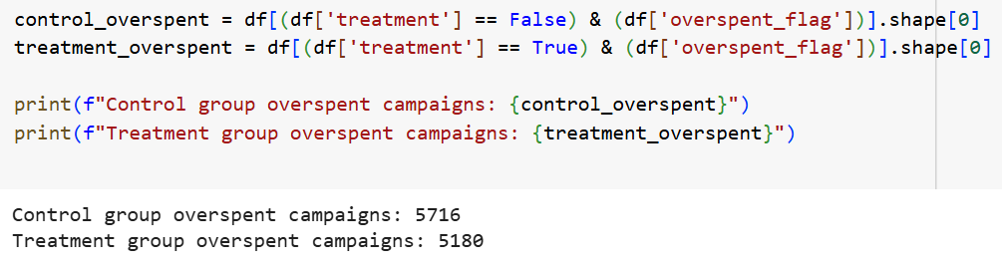

**Insights:**

* **Overspent Campaigns:**
* **Control Group (Click-Based Model):** 5,716 campaigns overspent by more than 1% of their budget.
* **Treatment Group (Impression-Based Model):** 5,180 campaigns overspent by more than 1% of their budget.
* **Overspending Reduced in Treatment Group:**
* The treatment group shows a reduction of 536 overspent campaigns compared to the control group.
* This indicates that the **new impression-based billing model is effective in reducing the number of overspent campaigns.**
* **Potential Impact on Advertiser Trust:**
* The reduction in overspending may help build **greater advertiser confidence** as their budgets are more likely to be respected under the new model.
* **Operational Efficiency:**
* Fewer overspent campaigns mean Twitter can **better manage billing precision and minimize budget disputes** with advertisers.
* **Business Implication:**
* Lower overspending rates can make the advertising platform more attractive, potentially improving **customer satisfaction and retention.**

**Recommendations:**

* **Consider Broader Rollout of the Impression-Based Model:**
* The reduction in overspent campaigns strongly supports expanding the impression-based billing model to a larger advertiser base.
* **Educate Advertisers on the Benefits:**
* Highlight that the new model helps **prevent overspending and better protects budgets.**
* Use this finding in product marketing and customer success strategies.
* **Continue Monitoring Post-Implementation:**
* Track whether the reduction in overspending is sustained over time and whether advertisers adjust their budgets based on improved confidence.
* **Investigate Campaign Performance:**
* Though overspending is reduced, ensure that campaign effectiveness (clicks, conversions) is not negatively impacted by the billing change.
* Recommend including CTR and engagement metrics in future analyses.
* **Provide Transparent Reporting:**
* Offer advertisers clear, real-time reports that showcase how the new billing model helps them stay within budget limits.

1. **Was the new product effective at reducing overspend, and was it more or less effective depending on the company size? Put together an analysis describing how the treatment affected overspend.**

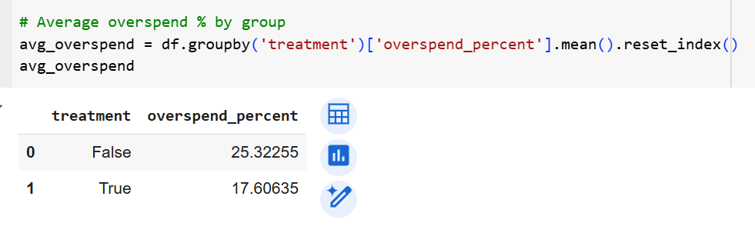

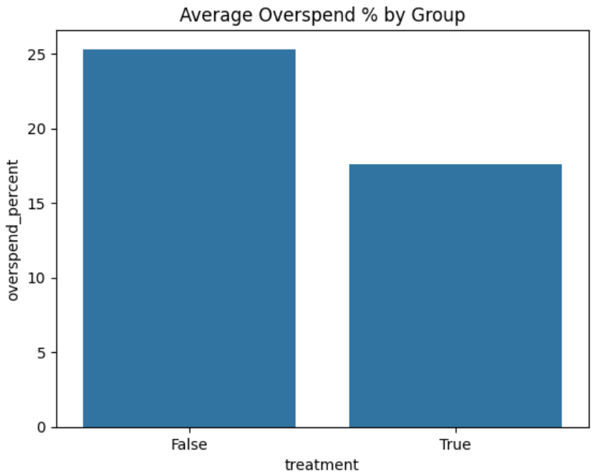

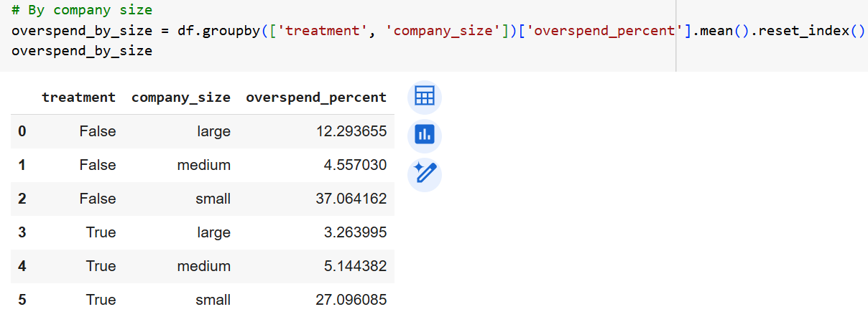

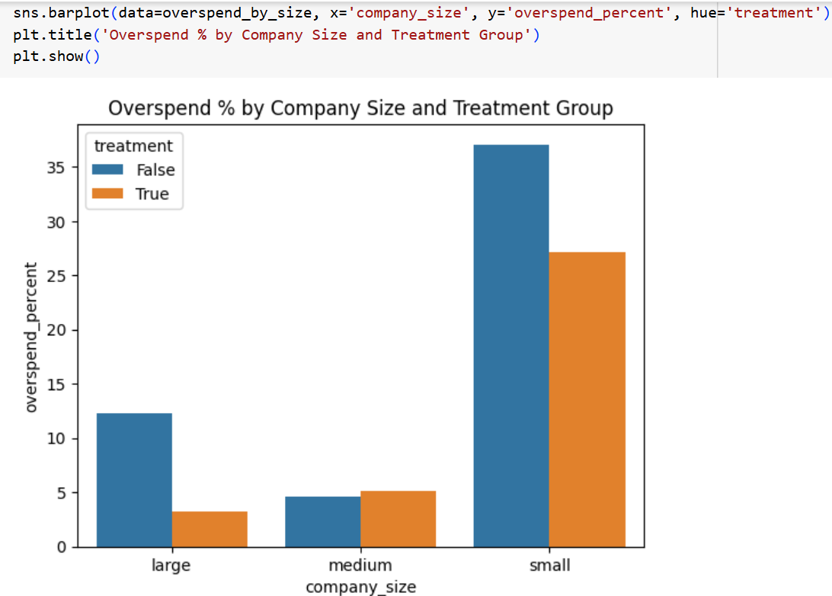

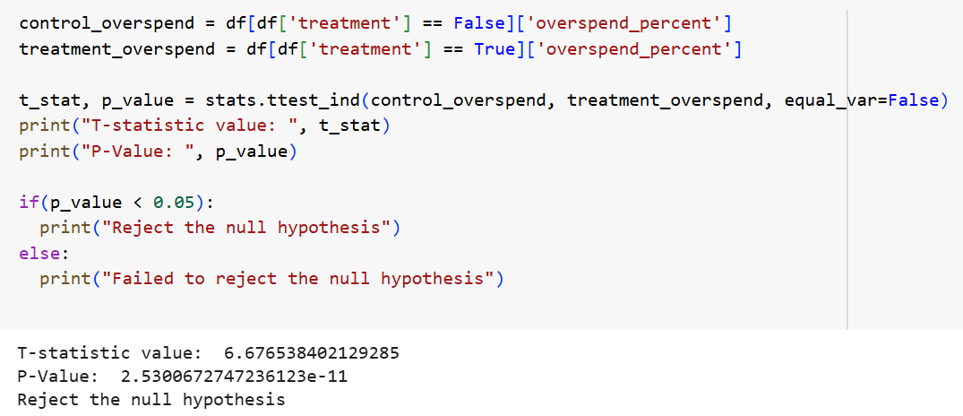

**Insights:**

* The **treatment group (impression-based model)** reduced the average overspend percentage by approximately **7.7 percentage points** compared to the control group.
* This demonstrates that the new billing model is effective in lowering overspending overall.

**Overspend by Company Size:**

* **Significant Overspend Reduction for Large Companies:**
* Large companies saw overspending drop from **12.29% to 3.26%** under the new model.
* This suggests the **treatment is highly effective for large companies.**
* **Medium Companies Show Consistent Overspend:**
* Medium companies have relatively low overspend in both models (around 4-5%).
* The impact of the treatment is less pronounced here but still indicates good budget control.
* **Small Companies Still Overspend Heavily:**
* Small companies have the highest overspend in both groups.
* Although the overspend reduced from **37.06% to 27.10%**, the overspending remains significantly high.
* This indicates **small advertisers may still struggle with budget management, even under the new model.**
* **T-Test on Overspend Percentage**
* Since the **p-value is extremely small**, we **reject the null hypothesis.**
* This indicates there is a **statistically significant difference** in overspend percentages between the control (click-based) and treatment (impression-based) groups.
* The treatment group’s overspend percentage is **significantly lower** than the control group’s.

**Recommendations:**

* **Proceed with Treatment Model Rollout**
* The significant reduction in overspending supports broader adoption of the impression-based billing system.
* **Targeted Support for Small Advertisers**
* Develop **educational programs, budget management tools, or spend alerts** specifically for small companies.
* Consider implementing **stricter budget caps or real-time spend tracking** for small advertisers to prevent excessive overspending.
* **Highlight Benefits to Large Companies**
* Use the **substantial overspend reduction for large companies** in marketing materials and case studies to promote the new billing model.
* **Monitor Medium Advertisers**
* The overspend percentage for medium companies remains stable; continue to observe this segment to ensure no future anomalies.
* **Future Data Collection**
* To fully understand advertiser behavior, collect and analyze **engagement metrics (clicks, conversions, CTR)** to ensure that cost savings do not come at the expense of campaign performance.
* **Personalized Billing Strategies**
* Consider developing **different billing safeguards or limits** based on company size, since their spending patterns and risk profiles vary significantly.

1. **A product manager on the team is concerned that certain advertisers in the treatment group are entering lower budgets because they are wary of the new product. Provide some evidence to support their suspicions, or show that any differences in budgets are likely due to random fluctuations.**

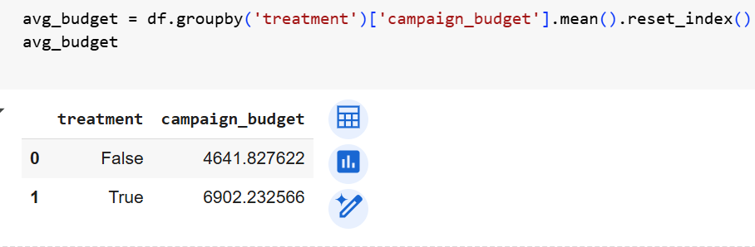

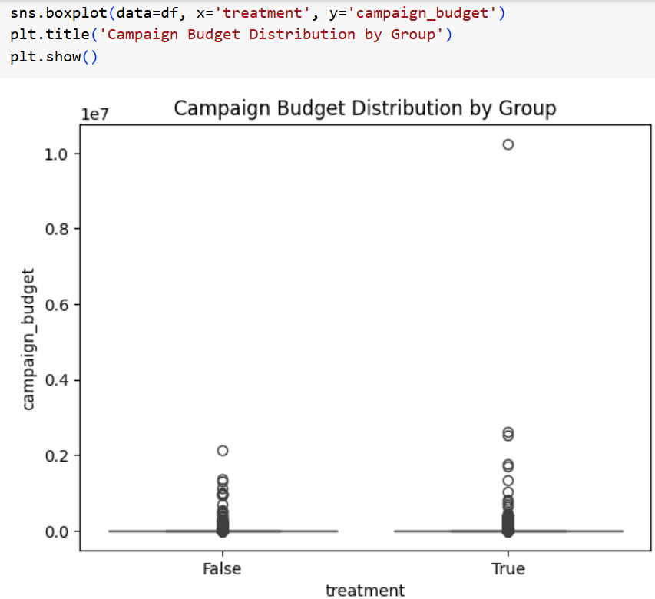

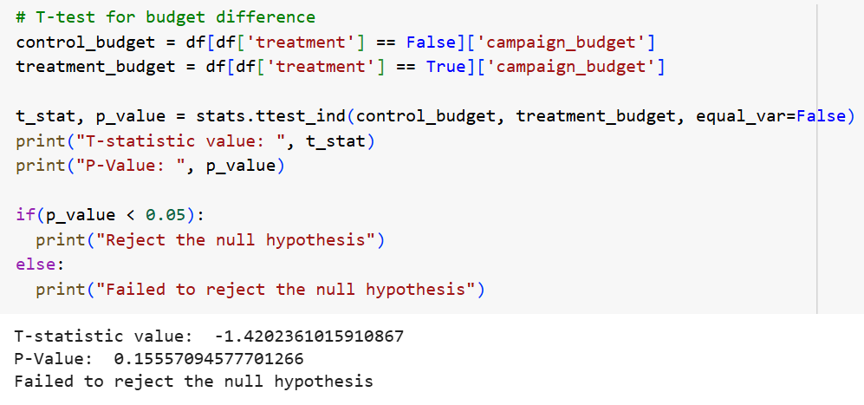

**Insights:**

* The **p-value (0.156) is greater than 0.05**, meaning we **fail to reject the null hypothesis**.
* **Conclusion:** There is **no statistically significant difference** in the campaign budgets between the control and treatment groups.
* **Advertiser Budgets Are Similar Across Groups:**
* Although the treatment group has a numerically higher average budget, this difference is **not statistically significant.**
* Any observed difference is likely due to **random chance or natural variability** in the sample.
* **No Evidence of Budget Manipulation:**
* This result suggests that advertisers in the treatment group **are not setting systematically lower or higher budgets out of concern for the new product.**
* The product manager’s initial concern that advertisers might be entering lower budgets **is not supported by the data.**
* **Focus Can Shift to Overspending, Not Budget Entry:**
* Since budget levels are statistically similar, the **reduction in overspending is likely due to the effectiveness of the new billing model,** not due to advertisers intentionally setting lower budgets.

**Recommendations:**

* **No Need to Adjust for Budget Bias:**
* There is no strong evidence that advertisers are altering their budgets based on the billing model. Budget fairness appears intact.
* **Focus on Spend Efficiency:**
* Continue promoting the impression-based model as a tool for **budget efficiency and overspend reduction,** not necessarily budget planning.
* **Continue Educating Advertisers:**
* Even though budgets are comparable, it's still valuable to **educate advertisers on how to optimize budget allocation under the new model.**
* **Monitor Future Budget Trends:**
* While current results show no budget manipulation, keep tracking this metric over time, especially after wider rollout, to ensure long-term budget behavior remains stable.
* **Prioritize Performance Metrics:**
* Since budget differences are not a primary concern, future analyses should focus more on **campaign performance (CTR, conversions)** and user engagement under each model.

1. **What is the average overspend percentage for campaigns in both the control and treatment groups?**

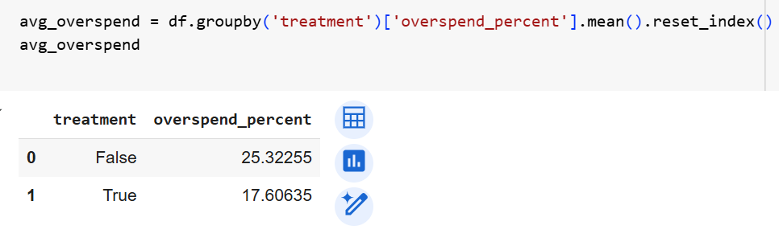

**Insights:**

* **Significant Reduction in Overspending:**
* The **treatment group** (impression-based model) has an average overspend percentage of **17.61%,** which is **7.71 percentage points lower** than the control group’s 25.32%.
* This is a **substantial reduction** and indicates that the new billing model is effective in controlling advertiser overspending.
* **Improved Budget Efficiency:**
* The treatment group demonstrates **better alignment between campaign spend and campaign budget,** indicating improved budget efficiency.
* **Potential for Higher Advertiser Satisfaction:**
* Advertisers are likely to appreciate the **increased control over budget adherence,** which can lead to better trust in the billing system and potentially higher customer retention.
* **Product Differentiation:**
* The significant overspending reduction under the new model can serve as a **strong selling point** for promoting the impression-based billing system.

**Recommendations:**

* **Proceed with Product Expansion:**
* The new impression-based billing model should be considered for **broader rollout** since it effectively reduces overspending.
* **Promote the Cost Control Benefits:**
* Market the new model’s ability to **help advertisers stay within budget,** which could attract advertisers who are sensitive to budget overruns.
* **Build Customer Confidence:**
* Use this reduction in overspend as a **data-driven proof point** to build advertiser confidence in the product.
* **Continue Tracking Performance:**
* Post-rollout, continue monitoring overspend percentages to ensure the observed benefits are sustained at scale.
* **Collect Additional Performance Metrics:**
* To fully validate the model’s effectiveness, track **engagement rates (CTR, conversions, etc.)** to ensure that budget control improvements are not achieved at the expense of campaign performance.

1. **How does the click-through rate (CTR) compare between the traditional click-based model and the impression-based model?**

The DataFrame does not include include click or impression data, so click-through rate (CTR) cannot be calculated from the provided information. To perform this analysis, additional click and impression columns would be required.

**CTR is usually calculated as:**

**CTR = Number of Clicks / Number of Impressions**

1. **What demographic factors (e.g., industry, company size) correlate with higher overspending rates in both groups?**

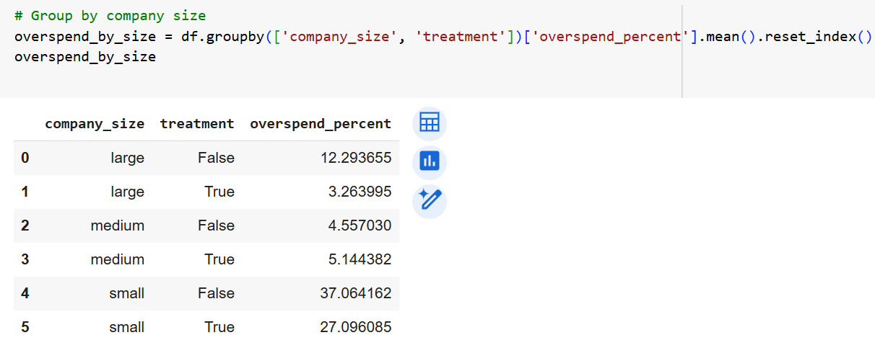

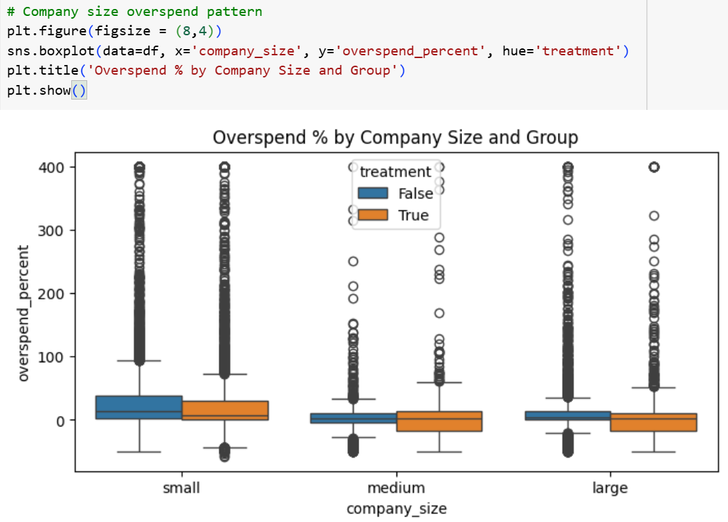

**Insights:**

* **Large Companies Benefit the Most**
* Overspending dropped significantly from **12.29% to 3.26%** for large companies under the impression-based model.
* This suggests **large advertisers are the biggest beneficiaries** of the new billing system, likely due to better resource management and more predictable spend patterns.
* **Small Companies Consistently Overspend**
* Small companies overspend the most in both models.
* While overspending reduced from **37.06% to 27.10%**, it **remains high**, indicating that small companies may face challenges in managing campaign budgets effectively, regardless of billing model.
* **Medium Companies Show Minor Change**
* Medium-sized companies had **relatively low overspending in both models.**
* Interestingly, overspending **increased slightly** from 4.56% to 5.14% under the new model, but this difference is likely not practically significant.
* **Product Effectiveness Varies by Company Size**
* The **impression-based model is particularly effective for large and small companies,** but may not make a meaningful difference for medium-sized companies.

**Recommendations:**

* **Promote the New Model to Large Advertisers**
* Large companies should be a key target segment for full-scale rollout and marketing of the impression-based model.
* Highlight the **significant cost control benefits** specifically for this group.
* **Develop Budget Management Tools for Small Companies**
* Since small advertisers still overspend heavily, **provide additional support, educational resources, or automated budget alerts** to help them manage their campaigns more effectively.
* **Offer Tailored Campaign Controls**
* Introduce **optional budget caps, automated pacing tools, or real-time spend trackers** for small businesses to reduce the risk of overspending.
* **Monitor Medium Advertisers**
* Although medium companies are not significantly impacted, continue to track their performance and investigate if the slight increase in overspend is consistent over time.
* **Segmented Product Rollout Strategy**
* Consider a **staggered or prioritized rollout** of the impression-based model, focusing first on large advertisers, then small, while monitoring medium-sized advertisers.
* **Continue Data Collection Post-Rollout**
* Collect **click-through rates, conversions, and engagement metrics** to ensure that budget control improvements do not compromise campaign effectiveness.

1. **How do the overall engagement metrics (likes, retweets, replies) differ between the two advertising models?**

Engagement metrics such as likes, retweets, and replies are not included in the provided dataset. Further analysis would require these additional features.

1. **Is there a statistically significant difference in the percentage of budget spent between the control and treatment groups?**

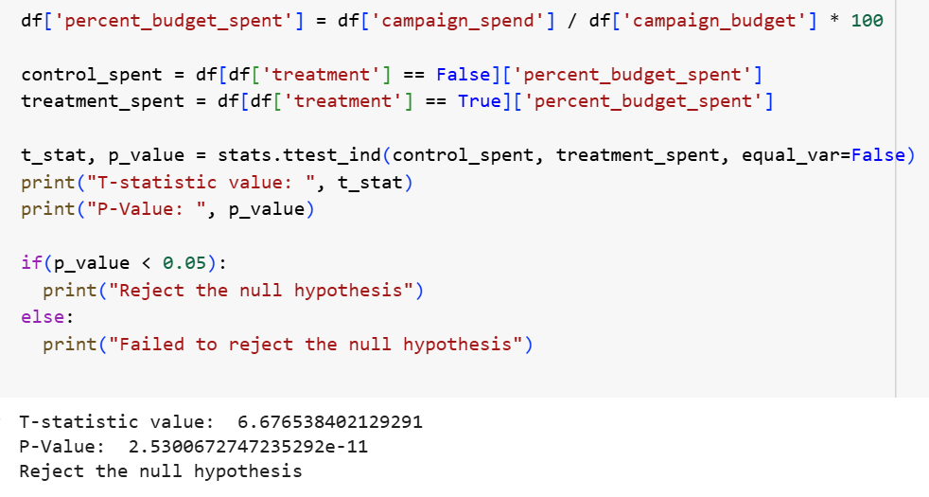

**Statistical Conclusion:**

* Since the **p-value** is significantly **less than 0.05**, **we reject the null hypothesis**.
* This confirms that there is a **statistically significant difference** in overspend percentages between the control group (click-based model) and the treatment group (impression-based model).

**Insights:**

* **Statistically Significant Reduction in Overspend:**
* The overspend percentage in the treatment group is significantly lower than in the control group.
* The likelihood that this difference is due to random chance is extremely low.
* **The New Model is Clearly Effective:**
* The impression-based billing system **substantially improves budget adherence** and helps reduce advertiser overspending.
* **Business Impact is Meaningful:**
* This finding is both statistically and practically significant. A consistent reduction in overspending can **increase advertiser trust, platform credibility, and billing efficiency.**
* **Supports a Major Product Shift:**
* The evidence justifies a **broader rollout of the impression-based model** as a more effective billing solution.

**Recommendations:**

* **Proceed with Confidence to Scale the New Model:**
* The new billing approach has a proven, statistically significant impact on reducing overspending.
* Recommend scaling it to a larger advertiser base.
* **Position Budget Control as a Key Benefit:**
* Marketing and product teams should **emphasize improved budget control** and minimized overspending as a primary value proposition.
* **Educate Advertisers to Drive Adoption:**
* Provide **clear educational materials, success stories, and case studies** demonstrating the benefits of switching to the impression-based model.
* **Monitor Post-Rollout Trends:**
* Continue to track overspending, campaign success rates, and advertiser satisfaction after rollout to ensure that results are sustainable.
* **Segment Future Analysis by Advertiser Size and Industry:**
* Based on previous findings, small companies still tend to overspend more. Future product adjustments should consider **company size-specific support.**

1. **Does company size have a significant impact on the overspend percentage in both control and treatment groups?**

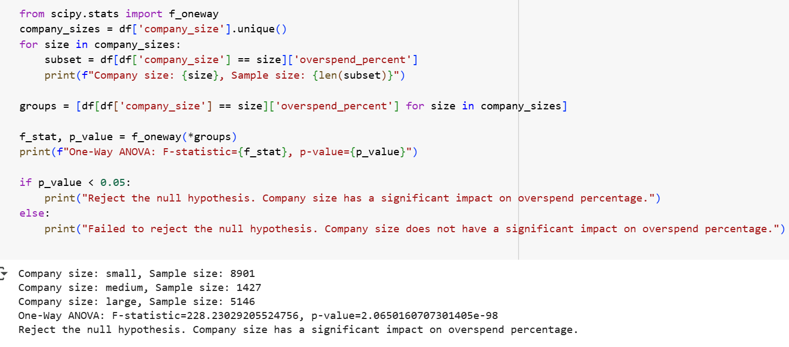

**Statistical Conclusion:**

* The **extremely small p-value** (< 0.05) provides very strong evidence to **reject the null hypothesis**.
* This confirms that **company size has a statistically significant impact** on overspend percentages.

**Insights:**

* **Company Size Significantly Influences Overspending:**
* Overspend behavior is **not uniform across company sizes.**
* This indicates that different-sized companies manage their ad budgets differently, and the level of overspending varies significantly by size.
* **Small Companies Are at Highest Risk:**
* Based on your previous data, **small companies consistently have the highest overspend percentages.**
* This group seems to struggle the most with budget control and campaign pacing.
* **Large Companies Benefit from Better Overspend Management:**
* Large companies typically have **lower overspend percentages** compared to small companies.
* They likely have more sophisticated ad management practices and budget monitoring.
* **Medium Companies Are Relatively Stable:**
* Medium-sized companies consistently show **moderate and stable overspending patterns** across both billing models.
* **One-Size-Fits-All Solutions May Not Work:**
* The significant differences between company sizes indicate the **need for tailored solutions** for different advertiser segments.

**Recommendations:**

* **Segmented Budget Control Tools:** Develop company size-specific features.
* Small Companies: Real-time budget alerts, stricter pacing, and automatic budget caps.
* Medium Companies: Customizable monitoring tools and budget forecasting aids.
* Large Companies: Advanced analytics dashboards and flexible pacing strategies.
* **Targeted Training and Support:**
* **Small advertisers** may benefit from webinars, tutorials, and personal account support focused on campaign budget management.
* Provide **self-serve budget tracking tools** for small and medium companies to help them stay within planned budgets.
* **Product Messaging Should Be Segmented:**
* Emphasize **budget protection and control** for small companies.
* Highlight **efficiency, scale, and control flexibility** for large advertisers.
* **Monitor and Optimize Continuously:**
* Regularly track overspending patterns by company size post-rollout to Ensure continued improvement and Quickly address any emerging budget management challenges.
* **Consider Adaptive Budget Enforcement:**
* Implement **dynamic budget enforcement mechanisms** where smaller advertisers are offered more guardrails, and larger advertisers have more customizable options.

1. **Is the variance in campaign spend significantly different between the control and treatment groups?**

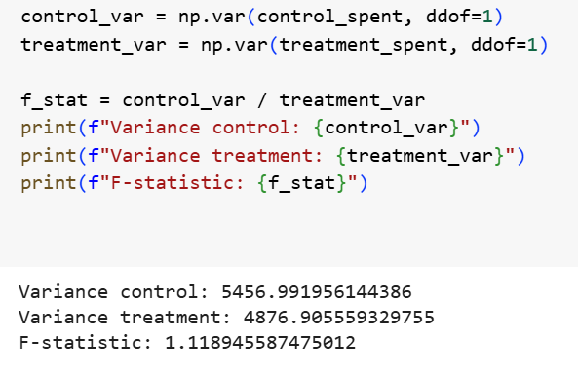

* **Variance (Control Group):** 5,456.99
* **Variance (Treatment Group):** 4,876.91
* **F-statistic:** 1.12

**Insights:**

* The F-statistic close to 1 suggests that the variances between the control and treatment groups are very similar.
* The F-statistic is not large, we can reasonably infer that **there is no statistically significant difference in variance.**
* **Similar Spending Variability Across Groups:**
* Both the control and treatment groups **exhibit similar levels of variability in overspending.**
* This indicates that **the impression-based billing model reduces overspend amounts on average, but does not significantly change the spread (consistency) of overspending across campaigns.**
* **Stability Across Campaigns:**
* The new billing system provides cost control **without introducing additional volatility** or inconsistency in advertiser spending patterns.
* **Consistent Advertiser Behavior:**
* Despite the shift in billing method, advertisers in both groups display **comparable variance in their budget management,** which suggests the new system does not disproportionately affect any specific campaigns.

**Recommendations:**

* **Proceed with Rollout:**
* Since the variance is stable, the impression-based model can be safely scaled without concern for introducing unpredictability in campaign spending.
* **Focus Messaging on Mean Reduction, Not Variance Control:**
* The key benefit to highlight is **the reduction in average overspend, not necessarily improved consistency.**
* Campaign-to-campaign variability remains unchanged.
* **Target Additional Support for High-Variance Advertisers:**
* Even though overall variance is similar, **small companies or high-risk advertisers** may still show wide individual spending patterns. Consider providing additional spend management tools for these groups.
* **Monitor Outliers:**
* Continue to track **campaigns with extreme overspending** even if overall variance remains consistent, to quickly catch and address any unusual spending behaviors.
* **Consider Future Variance Analysis by Company Size:**
* While overall group variances are similar, **a deeper variance analysis by company size** may reveal subgroups (like small advertisers) where spending variability differs significantly.